# Brandon Hogue

# IR Audio Data Sheet

This module holds audio files in the form of WAV or OGG on the onboard flash EEPROM. It is triggered by pulling a trigger pin to ground. Each sound file is named accordingly (T01.WAV, etc).

# PCB Layout:

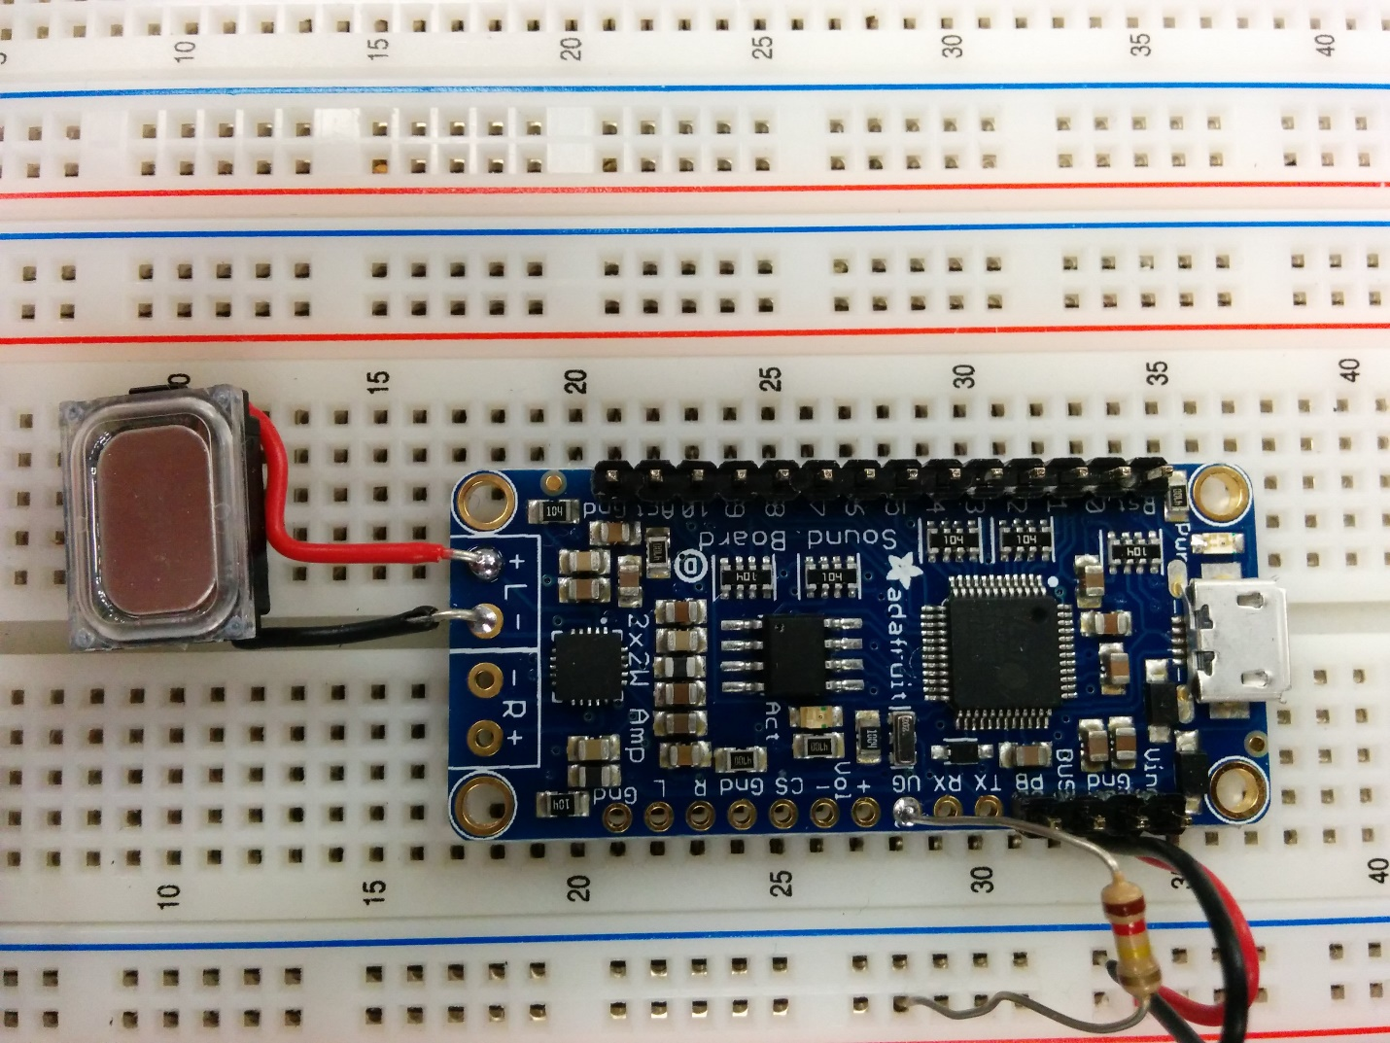

# Hardware Inputs:

|  |  |  |
| --- | --- | --- |
| Input Name | Description of Signal | Expected Range |
| 5V | --- | Up to 250mA |
| GND | --- | --- |
| UG | Tied to VDD to allow trigger mode | 5V |
| Trigger0 | Used to trigger sounds when pulled to ground | 0V or 5V |
| Trigger1 | Used to trigger sounds when pulled to ground | 0V or 5V |
| Speaker(+) | Positive Speaker Output | Analog Audio |
| Speaker(-) | Negative Speaker Output | Analog Audio |

# Software:

|  |  |  |  |
| --- | --- | --- | --- |
| Function Name | Description | Input Parameters | Return Value |
| SendSound | Plays sound file | SoundFile | N/A |